Clayton County Public Schools Athletics
Student Documentation

Prior to any activity & participation in athletics,
these requirements must be met.

Mandated Documentation Prior to Participation (Conditioning/Tryouts/Practice/Games) for all student-athletes.

All documentation is required to be in DragonFly.

Documents Required:
- CCPS Return to Participation Waiver and Guidelines forms
- Physical
- Insurance waiver with policy information
- Concussion-awareness form
- Heat & Illness awareness form
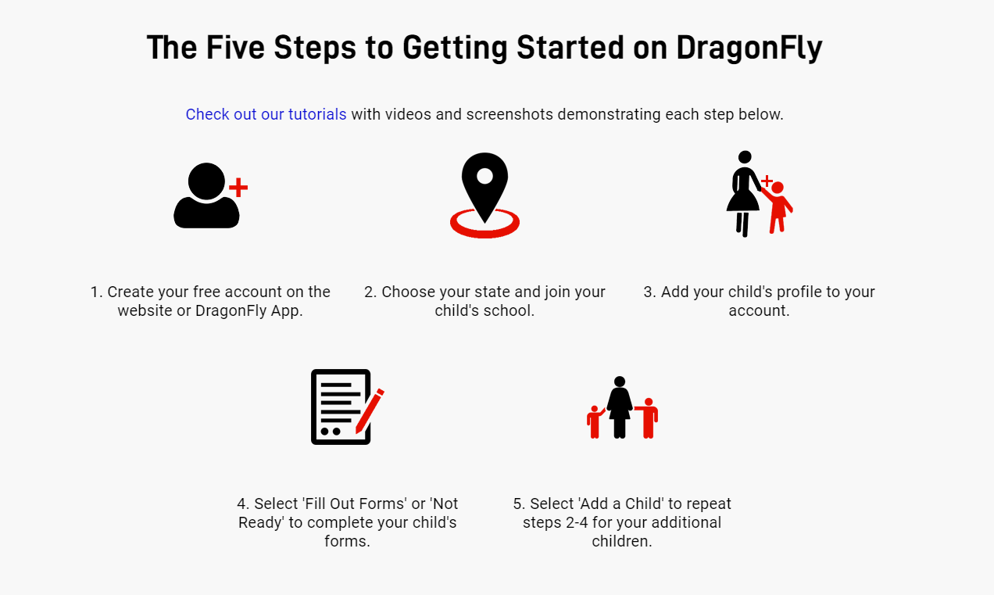
- Sudden Cardiac Arrest awareness form

